Progressing Toward Proficiency
Lynn Johnston
Day One:
- Model and Teach Greeting http://www.lynnjohnston.com/?p=52

- Intro song of the week: Buenos Dias https://youtu.be/9ZKw5IldE9Y
Bonjour https://youtu.be/RkQrLXaEOTg

- Coca cola commercial in Spanish with me llamo and name https://youtu.be/v5UUwuNnbuY
Clip from Friends Je m’appelle w Joey https://youtu.be/H3dToD7_ATU

Attendence: Yo me llamo Senora Johnston. Como te llamas?
Je m’appelle Madame Johnston, et toi? Comment t’appelles-tu?
Count number of students
Number of boys
Number of girls
Total

- 5 minute Sample write- Write directions on the board in English. List all the words you know in the target language, write in sentences if you can describe yourself and your interests.

- Model levels with introduction to my family and proficiency levels. Draw stick people representations of my family and describe them demonstrating novice low and intermediate low proficiency levels.

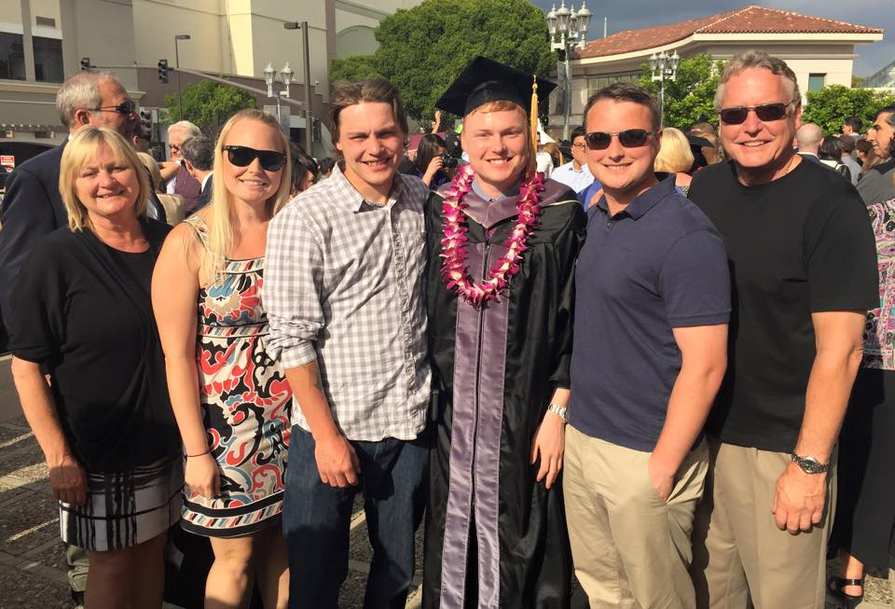

- Introduce the path to proficiency via doc camera, handout, and bulletin board. 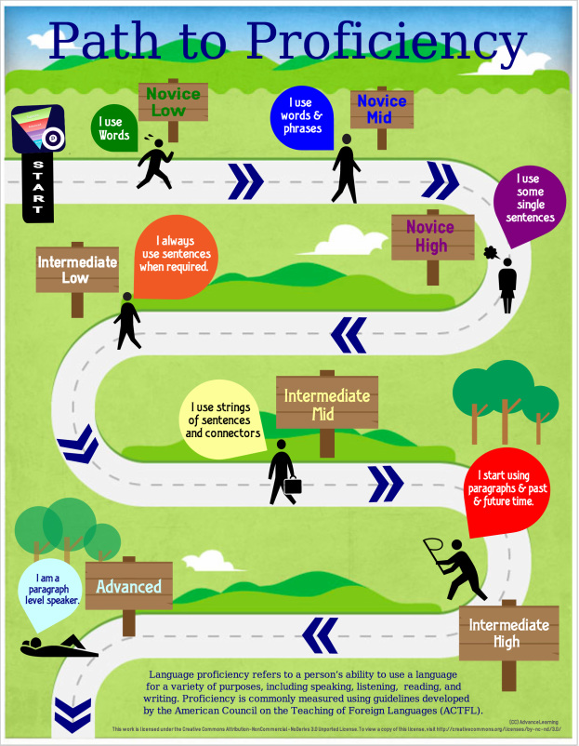

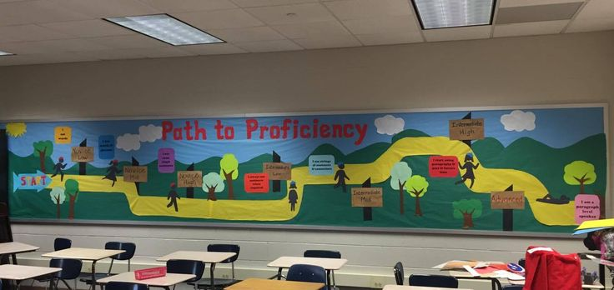

- Form groups of students for Circus activity to practice proficiency levels. http://scsworldlanguages.weebly.com/activities--strategies.html

- Closure and reflection: Students copy levels into notebook and give an example of each level in English, and current level. Found this little gem on the SCSworldlanguage.weebly. 