Coming to the University of Washington…
TELL COLLAB 2017 January 21-22, 2017
Saturday 8:30 am-6:30 pm | Sunday 8:30 am – 2:30 pm
Learn more at… http://www.tellcollabseattle.org/
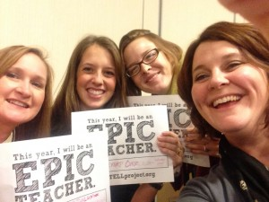
Embracing a participant-driven model of learning, the TELL Collab is a professional learning experience that allows educators to engage in the very practices of effective learning they are expected develop in their own language teaching environment. Over the course of the experience, participants will be challenged to become active learning leaders in a variety of settings that ask them to explore, model and share effective language learning practices identified in the TELL Framework.

How TELL Collab Empowers Participants
The TELL Collab fosters professional conversations and deep learning experiences with national experts, teacher leaders, and colleagues. The goal is to empower participants to take control of their own professional learning.
TRADITIONAL CONFERENCE | TELL COLLAB
Set schedule developed by organizers | Participant-driven schedule based on professional learning needs
Series of speakers selected by organizers | Participants share resources to support professional learning needs
Pre-determined content | Participants able to personalize content
Notebook full of good ideas with possibly no time to process how to use them | Participants leave with idea(s) AND strategies for implementing them
Sessions may be so large that participant interaction becomes minimal | Participants actively work in a variety of small group settings
Professional credit based on seat-time | Participants earn performance-based badges that “show what they know”
Registration: $99 by 12/31/2016; $129 on site
TELL = Teacher Effectiveness for Language Learning

