- Eric Carle

De la cabeza a los pies (From Head to Toe) by Eric Carle, Eric Carle (Illustrator)
This is a great pattern book with beautiful illustrations typical of Eric Carle. It makes a fun read aloud. It is useful for teaching body parts and animal vocabulary. The basic plot is different animals say “I can move my arms, or clap my hands, stomp my feet, can you do that to” and a different children say “of course I can” and do the same move.
This could be used for a movement activity. Students act out animal actions while saying “claro que si” of course I can.
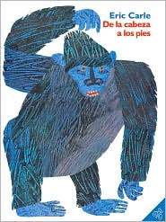

Oso pardo, oso pardo, ¿qué ves ahí? (Brown Bear, Brown Bear, What Do You See?) by Bill Martin, Jr., Eric Carle (Illustrator), Teresa Mlawer (Translator)

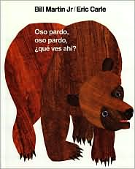
This is another great pattern book with great illustrations. It is useful for teaching animals and colors. The rhyming pattern makes it a fun read aloud. It starts out “brown bear, brown bear what do you see, I see a red bird looking at me” and then continues on with the red bird and keeps adding in different animals and colors. It will be useful in having the students predict what will be the next animal and color.

La oruga muy hambrienta by Eric Carle, Eric Carle (Illustrator)

This is a well loved pattern book instantly recognized by many students. The vocabulary is a little harder than the other Eric Carle books I have selected but most of the students know the story line. I little caterpillar is very hungry and eats one red apple Monday, two green pears Tuesday and so forth. He finally is big and fat and builds a cocoon and turns into a butterfly. It has lots of good vocabulary useful for teaching days, food, numbers, and counting. I will use this during our food unit. It would also be a good introduction to the past tense.
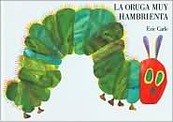

La Mariquita Malhumorada (The Grouchy Ladybug) by Eric Carle, Eric Carle (Illustrator), Teresa Mlawer (Translator), Teresa Mlawer (Translator)
A grouchy ladybug looking for a fight challenges everyone she meets no matter what their size or strength. This is another great pattern book with nice illustrations well known to many students. It has a little more difficult vocabulary but after the pattern is established it becomes easier to figure out the story line because so many of the words are repeated over and over again. It will be good for teaching time, and animals.

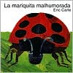

Does a Kangaroo Have a Mother, Too?: El canguro tiene mama? by Eric Carle, Teresa Mlawer, Eric Carle (Illustrator)

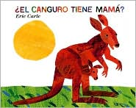
This is another great pattern book. It’s a good read aloud with really nice illustrations. It is useful for teaching animal vocabulary. It includes names for groups of animals in Spanish as well as the male, female, and baby name for animals. This would be a good sample for students to make their own pattern books.
- Dr. Seuss

Huevos verdes con jamón (Green Eggs and Ham) by Dr. Seuss, Aida E. Marcuse, Aida E. Marcuse (Translator), Marcuse Aida (Translator)

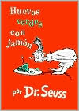
Dr. Seuss turns 50 simple words into magic in this time-honored classic. Sam-I-am won't give up! He keeps trying to get the grumpy grown-up in the story to taste green eggs and ham. No matter how Sam-I-am presents the green eggs and ham (in a box, with a fox, in the rain, on a train), the curmudgeon refuses to try them. Finally, Sam-I-am's pesky persistence pays off. A crowd of open-mouthed onlookers watch in suspense as the old grouch takes a bite. And?...SAY! The old sourpuss's face is wreathed in smiles as he gratefully acknowledges, "I do so like green eggs and ham. Thank you, thank you, Sam-I-am!"

Un pez, dos peces, pez rojo, pez azul by Dr. Seuss, Dr. Suess, Yanitzia Canetti

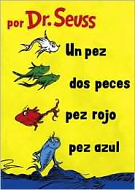
This nonsensical romp through a gallery of imaginary creatures introduces beginning readers to a variety of rhyming letter combinations. Meet the Yink, who likes to wink and drink pink ink. Or the Yop, who hops from finger top to finger top. Then there is morose Ned who doesn't like his little bed. The short anecdotal poems have just the right combination of humor and the fantastic to enrapture readers.

The Cat in the Hat (Spanish Beginner Books Series) by Dr. Seuss, Carlos Rivera (Translator)

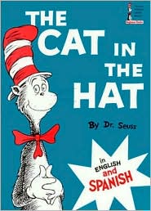
One wet, rainy day while mother is out, a boy and a girl sit dejectedly in their chairs, watching the rain beat against the window. They're bored. Suddenly, in bursts a large cat in a tall striped hat, ready to play - and not just ordinary games, oh no! This cat likes to create mischief and mayhem, and to aid him, he brings Thing One and Thing Two. These two small fuzzy blue imps race around the house, wreaking havoc. Who's going to clean up this mess? This most famous of all the Beginner Books has been beloved by readers young and old since 1957.

¡Yo puedo leer con los ojos cerrados! by Dr. Seuss, Yanitzia Canetti (Illustrator) , Yanitzia Canetti (Translator)

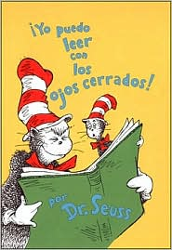
I can read with my eyes shut.

Rebecca Emberly

My Animals/ Mis animales by Rebecca Emberley, Rebecca Emberley (Illustrator)
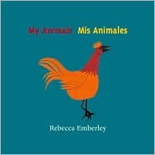
This is a very simple book for the very beginning reader. It has a picture of an animal and the word in Spanish and English on each page. There are fifteen animals in all. It would be good as an introduction to our animal unit and for students at a very low reading level who frustrate easily trying to do silent reading in Spanish.

My Clothes/Mi Ropa by Rebecca Emberley, Rebecca Emberley (Illustrator)

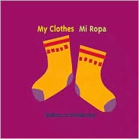
This is another very simple book for my low readers. It basically gives them a picture of a clothing item and the words in Spanish and English. I have several student from the Academy (our school within a school for students reading below a fourth grade level). These books allow them to participate in sustained silent reading without getting too frustrated.

My House, Mi Casa by Rebecca Emberley, Rebecca Emberley (Illustrator)

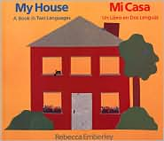
This book is also written in both languages English and Spanish. It is useful for teaching the rooms in the house and items in each room. It has more vocabulary and is a little more difficult than her other books. Also there are sentences instead of just words but not much of a story line.

Laurel Porter-Gaylord

Quiero a mi papá porque... (I Love My Daddy Because...) by Laurel Porter-Gaylord, Eida De Vega, Ashley Wolff (Illustrator), Ashley Wolff (Illustrator)

- 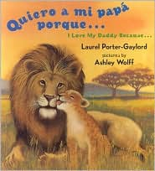
This book is in Spanish with English translations. This is useful for animal vocabulary especially father and baby names of animals for example: Bald Eagle and chick or Beaver and Kit. This book has great pictures. It gives several reasons for why we love our dads. Could be used as a mentor book for reasons why we love our dads.

Quiero a mi mamá porque...(I Love My Mommy Because...) by Laurel Porter-Gaylord, Ashley Wolff (Illustrator)

This book has Spanish with English translations on the same page. This is useful for animal vocabulary like mom and baby vocabulary. It also has great pictures. It gives lots of reasons why we love our moms. It wold be a good mentor book for writing the names of animals correctly in Spanish.
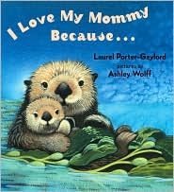

Eric Hill

Spot Va a la Escuela/Spot Goes to School by Eric Hill

School is fun -- there's so much to see and do. First Spot will meet his teacher and classmates, then, it's time for music. Learning to spell, listening to a story, and painting a picture are just some of the things in store for Spot on his first day. This is a fun book with flaps to lift and find Spot. This book is in Spanish with no English translations however with the illustrations and a dictionary most of my students should have no problems with this book.

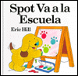

¿Dónde está Spot? by Eric Hill, Teresa Mlawer (Translator)
Children love books that pop-up, flip-flop, or have something special about them. Readers lift the flaps to reveal peek-a-boo surprises. Students love looking for Spot under the bed, in the closet, inside the clock, behind the door. This is good for teaching prepositions, things in the house, and the verb estar. It is only in Spanish without English translations but has simple controlled vocabulary. I will use it when I teach Where is... Donde esta?

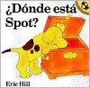

Sandra Cisneros & Carmen Lomas Garza

Hairs/Pelitos by Sandra Cisneros, Terry Ybanez (Illustrator)

This story from Hispanic author Sandra Cisneros’s book The House on Mango Street shows, through simple, intimate portraits, the diversity among us.
A girl describes how each person in the family has hair that looks and acts different, Papa's like a broom, Kiki's like fur, and Mama's with the sweet smell of bread. This is written in Spanish with English translations. It would be a great mentor book for teaching similies and adjectives.
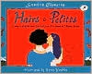

Family Pictures/ Cuadros de familia by Carmen Lomas Garza, Pat Mora, Carmen Lomas Garza (Illustrator), Sandra Cisneros (Introduction), Sandra Cisneros (Introduction)

Family Pictures is the story of Carmen Lomas Garza's girlhood: celebrating birthdays, making tamales, finding a hammerhead shark on the beach, picking cactus, going to a fair in Mexico, and confiding to her sister her dreams of becoming an artist. These day-to-day experiences are told through fourteen vignettes of art and a descriptive narrative, each focusing on a different aspect of traditional Mexican American culture. The English-Spanish text and vivid illustrations reflect the author's strong sense of family and community. For Mexican Americans, Carmen Lomas Garza offers a book that reflects their lives and traditions. For others, this work offers insights into a beautifully rich community. This will be useful for teaching culture and discussing what is happening in the pictures in Spanish.

Customer Reviews
Be the first to write a review!

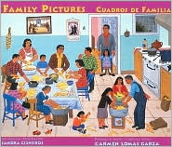

In My Family (En Mi Familia) by Carmen Lomas Garza, Harriet Rohmer, Harriet Rohmer (Editor), David Schecter (Editor), David Schecter (Editor)
In My Family/En mi familia is Carmen Lomas Garza's continuing tribute to the family and community that shaped her childhood and her life. Lomas Garza's vibrant paintings and warm personal stories depict memories of growing up in the traditional Mexican-American community of her hometown of Kingsville, Texas. I will use this with my family unit to compare and contrast family life in Mexico with family life in the United States.

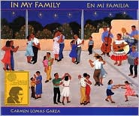

Counting Books

Mi amor por ti/My Love for You by Susan L. Roth
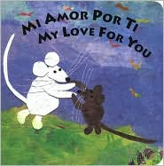
In both Spanish and English, two tiny mice express their love in big terms. On a walk together, the mice learn that their love is bigger than 1 bear, taller than 2 giraffes, larger than 3 blue whales. As they count from 1 to 10, the mice discover that their love is greater than anything they can imagine. Siempre. Forever.
This book is great for teaching comparison of adjectives and animal vocabulary.
To create the artwork for her books, Susan L. Roth uses paper from fourteen baskets in her studio, which are lined up by color. The animals in the book are created out of this paper.

El Pez Arco Iris by Marcus Pfister, Diego Lasconi, Ana Tortajada (Translator) , Diego Lasconi (Translator)

This is a counting book take off of the Rainbow Fish (who relinquishes his pride and gives away almost all of his special shiny scales to gain friends). This is useful for counting and sequencing. It has one crab, two whales, and so on up to ten fish. It introduces sea animal vocabulary. It is great to use as a pattern book for kids to create their own versions of counting books. It has eye-catching, holographic foil stamping for the fish scales. I am looking for the original book in Spanish to go along with this one.
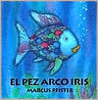

My Numbers / Mis números by Rebecca Emberley, Rebecca Emberley (Illustrator)
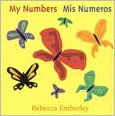
This is a simple counting book in Spanish and English. This would make a good mentor book for very beginning writers. Could be used for teaching numbers, plurals and other nouns including animals.
Alma Flor Ada

I Love Saturdays y domingos by Alma Flor Ada, Elivia Savadier (Illustrator), Elivia Savadier (Illustrator)

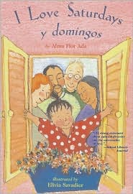
Saturdays and Sundays are very special days for the child in this story. On Saturdays, she visits Grandma and Grandpa, who come from a European-American background, and on Sundays — los domingos — she visits Abuelito y Abuelita, who are Mexican-American. While the two sets of grandparents are different in many ways, they also have a great deal in common — in particular, their love for their granddaughter.
While we follow our narrator to the circus and the pier, share stories from her grandparents' pasts, and celebrate her birthday, the depth and joy of both cultures are conveyed in Spanish and English. This affirmation of both heritages will speak to all children who want to know more about their own families and ethnic backgrounds. We will use this in our family unit to begin the discussion on how we treat the elderly and how often we see our grandparents while comparing and contrasting family traditions.

Mamá Goose: A Latino Nursery Treasury / Un tesoro de rimas infantiles by Alma Flor Ada, Alma Flor Ada, Isabel F. Campoy, Tracy Heffernan (Editor), Maribel Suarez (Illustrator)

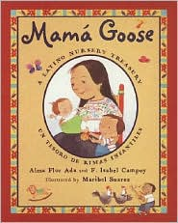
Alma Flor Ada and Isabel Campoy, acclaimed authors and scholars of Latino literature, have spent years culling popular and beloved lullabies, jump-rope songs, riddles, proverbs, and more from all over the Spanish-speaking world.
This book is rich with the diversity of Latino cultures and is the perfect introduction to Latino folklore for English speakers, and a trove of familiar favorites for Spanish speakers. The collection includes: Lullabies, Proverbs, Finger plays, Riddles, Lap games, Tall tales and never-ending stories, Sayings for various occasions, A ballad, Nursery rhymes, Songs, Jump-rope songs, Birthday songs, Song games, Christmas carols. I would like to incorporate some of these activities into my curriculum as well as having this book available to the kids for silent reading.

Pio Peep!: Traditional Spanish Nursery Rhymes by Alma Flor Ada (Selected by), Vivi Escriva (Illustrator), Alice Schertle (Adapted by), F. Isabel Campoy (Selected by)

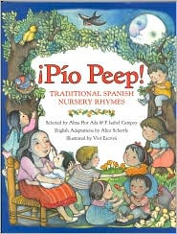
This is a bilingual collection of traditional rhymes that celebrate childhood and Spanish and Latin American heritage. From playing dress up to making tortillas, and from rising at daybreak to falling asleep, these joyful rhymes are sure to delight young readers.
Passed down from generation to generation, the twenty-nine rhymes included have been lovingly selected by distinguished authors Alma Flor Ada and F. Isabel Campoy. English adaptations by Alice Schertle capture the spirit of each rhyme and have a charm all their own. They are accompanied by enchanting illustrations by Spanish artist Viví Escrivá.
I would like to teach my students some of these nursery rhymes and compare and contrast them to Nursery rhymes in English.

Mediopollito (Half-Chicken) by Alma Flor Ada, Rosalma Zubizarreta, Alma Flor Ada, Kim Howard (Illustrator)

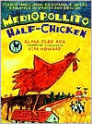
Why does a weather vane have a little rooster on the top, spinning around to tell us which way the wind is blowing? Here is the answer in this old story about Half-Chicken, who has one eye, one leg, and one wing. His adventures take him far and wide until he's carried straight to the top, in this lively retelling—in Spanish and English—of a traditional folktale. I am trying to create a collection and unit on Spanish folktales and this will be included as a choice for students to read.

