El Árbol Generoso Nombre_______________________

First teach Question Answer Relationships Using the Free lesson in Spanish from Martina Bex at Teacherspayteachers.com.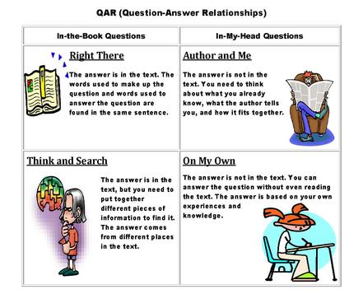
Right There: Does the boy love the tree? Write the words in Spanish that support your answer.
____________________________________________________________________________________________________________________________________________________________
Think and Search: How did the tree help the boy? List in Spanish.
______________________________________________________________________________________________________________________________________________________
Author and Me: What other benefits do trees provide us in addition to the ones mentioned in the story? List in Spanish and/or English.
____________________________________________________________________________________________________________________________________________________________
On My Own: What can we do to save the trees? List in Spanish or /English.

Your turn: Write a question from each one of the four categories for the book The Giving Tree,

Right There:____________________________________________________________________
Think and Search:________________________________________________________________
Author and Me:_________________________________________________________________
On My Own:____________________________________________________________________

- ¿El niño amaba el árbol ?

2. ¿Como ayudó al muchacho el árbol?
3. ¿Qué otros beneficios obtenemos de los árboles, además de los mencionados en la historia ?

4, ¿Qué podemos hacer para salvar a los árboles?

