L'Arbre Généreux Nom__________________________________________

First teach Question Answer Relationships Using the Free lesson with examples in French from Martina Bex at Teacherspayteachers.com.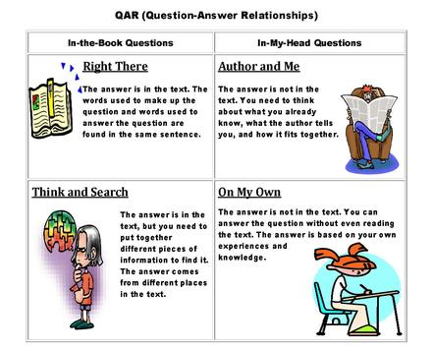
Right There: Did the boy love the tree? Write the words in French that support your answer.
__________________________________________________________________________________________________________________________________________________________________________________________________________________
Think and Search: How did the tree help the boy? List in French.
_________________________________________________________________________________________________________________________________________________________________________________________________________________
Author and Me: What other benefits do trees provide us in addition to the ones mentioned in the story? List in French and/or English.
__________________________________________________________________________________________________________________________________________________________________________________________________________________
On My Own: What can we do to save the trees? List in French or /English.

Your turn: Write a question from each one of the four categories for the book The Giving Tree.

Right There:____________________________________________________________________
Think and Search:________________________________________________________________
Author and Me:_________________________________________________________________
On My Own:____________________________________________________________________

- Le garçon aimait l' arbre?
- Comment l'arbre at-il aidé le garçon ?

- Quels autres avantages les arbres nous fournissent en plus de ceux mentionnés dans l'histoire?

- Que pouvons-nous faire pour sauver les arbres?

