Using Pattern Stories in the World Language Classroom

Helena Curtain helenacurtain@gmail.com

Pattern stories are stories in which scenes are repeated with some variation. Pattern or repetitive stories are very effective for language learning since they are a source of functional chunks of language that can be used as building blocks of communication. There is a core repeating structure or pattern that makes it possible to predict what comes next. Storylines, cultural sequences or concepts in repetitive/pattern stories are familiar to readers. The rhythm of pattern stories also helps to move the language into long-term memory. There are different types of pattern stories but what they have in common is that at least one element is repeated. Some pattern stories have several of the elements mentioned below.

**Common Types Of Pattern Stories**

1. Cumulative Story – each time a new event occurs, all previous events in the story are repeated.

2. Familiar Sequence— organized by recognizable them such as days of the week, numbers, months.

3. Question and Answer— the same or similar questions are repeated throughout the story

4. Repetition of a Phrase— word order in a sentence or phrase is repeated.

5. Rhyme— rhyming words, refrains, or patterns are used throughout the story.

6. Chain or Circular Story— plot is interlinked, the ending leads back to the beginning.

7. Songs— familiar songs with predictable elements such as a repetitive

***Cumulative Story***

Each time something new happens, all the other events in the story are repeated

|  |
| --- |
| **The Little Old Lady that Swallowed a Fly (Excerpt)**  There was an old lady who swallowed a bird  How absurd to swallow a bird  She swallowed the bird to catch the spider  She swallowed the spider to catch the fly  I don't know why she swallowed a fly - Perhaps she'll die  There was an old lady who swallowed a cat  Fancy that to swallow a cat  She swallowed the cat to catch the bird  She swallowed the bird to catch the spider  She swallowed the spider to catch the fly  I don't know why she swallowed a fly - Perhaps she'll die |

***Familiar or Logical Sequence***

The sequence can be days of the week, months of the year, seasons, the alphabet, numbers, colors…

Here is an example of several sequences. Of course, the story can happen using any tense.

|  |  |  |
| --- | --- | --- |
| They ate one ...  They ate two....  they ate three....  and so on... | First they ate…  Second they ate…  Third they ate…  and so on... | In January they ate…  In February they ate…  In March they ate…  and so on… |

The story of the Little Red Hen follows the sequence of planting and harvesting. It also has a repetitive phrase*.*

***Question and Answer***

A similar question is repeated in every part of the story.

|  |
| --- |
| When they were hungry do you know what they ate?  They ate....  When they were hungry do you know what they ate?  They ate....  When they were hungry do you know what they ate?  They ate... |

|  |
| --- |
| “Mirror, mirror on the wall, who’s the fairest of them all? “ |

***Repetition of a Phrase*** *--* A phrase or a sentence is repeated.



|  |
| --- |
| **Traditional Story: In a Dark Dark Wood**  In a dark dark wood there was a dark dark path.  And on the dark dark path there was a dark dark house.  And in the dark dark house, there was a dark dark (flight of) stairs.  And on top of the dark dark stairs, there was a dark dark room.  And in the dark dark room, there was a dark dark closet. (wardrobe, bureau)  And in the dark dark closet, (wardrobe, bureau) there was a dark dark box (chest).  And in the dark dark box (chest), there was…….  **A ghost!!!!!!!** |

|  |
| --- |
| **From Little Red Riding Hood**  What big eyes you have.  All the better to see you with, my dear.  What big ears you have.  All the better to hear you with, my dear.  What big teeth you have.  All the better to eat you with! |

***Rhyme*** *--* Rhyming words, or rhyming patterns are used throughout the story.

|  |
| --- |
| **From The Gingerbread Man**  Run, run, run  As fast as you can!  You can’t catch me  I’m the gingerbread man! |

***Chain or Circular Story*** *--* Plot moves in a circle and is linked since the ending leads back to the beginning.



|  |
| --- |
| ***Where the Wild Things Are*** by Maurice Sendak is an example of a circular story. Max was sent to his room because he was misbehaving. When he is in his room a magic forest appears and a boat that transports him to the land of the wild things. After many adventures he ends up back in his room and finds his supper on the table. This story is represented in a circular story map shown in |

***Songbooks***—Familiar songs with a repeating phrase or other predictable element. Examples of such books are:

|  |
| --- |
| The Wheels on the Bus  Mary Wore a Red Dress  This Old Man  Old McDonald Had a Farm |

**Teacher Written Pattern Stories**

Pattern stories are easy and fun to write and many teachers find that the stories they write for their students are especially well-suited for their learning targets. When teachers write their own stories they can focus on the functional language and vocabulary that the students need and place it within the a story that provides a meaningful context and an enjoyable experience with rhythm and patterns and of course has the satisfying narrative format of beginning, middle and end. Here are two stories written by Nick Staffa for his grade 3 Chinese students. You can see how the repetition can be helpful in building the students’ confidence and skills.

**What do you want to eat? by Nick Staffa (Memphis (TN) City Schools)**

Today is Monday, I want to eat chicken braised in soy sauce.

Today is Tuesday, I want to eat lamb skewers.

Today is Wednesday, I want to eat egg stir-fried rice.

Today is Thursday, I want to eat fried dumplings.

Today is Friday, I want to eat deep fried tofu.

Today is Saturday, I want to eat roasted beef.

Today is Sunday, I want to eat seasoned mixed noodles.

Now I’m full! Good-bye!

|  |  |  |  |
| --- | --- | --- | --- |
| :07.jpg | :3449765923232fp3;=ot>2353=768=566=XROQDF>2323--49893;;ot1lsi.jpeg | anchaofandezuofa.jpg | :1913070.jpg |
| 红烧鸡  hóngshāo jī | 羊肉串儿  yángròuchuànr | 蛋炒饭  dàn chǎofàn | 煎饺子  jiān jiǎozi |
| e6373e74ba421be3a97c99757ce77972.jpg | 3_200906071245465.attach.jpeg | :3004516_101414012938_2.jpg |  |
| 炸豆腐  zhádòufu | 烤牛肉  kǎo niúròu | 捞面  lāomiàn |  |

**What do You Like To Do? by Nick Staffa (Memphis (TN) City Schools)**

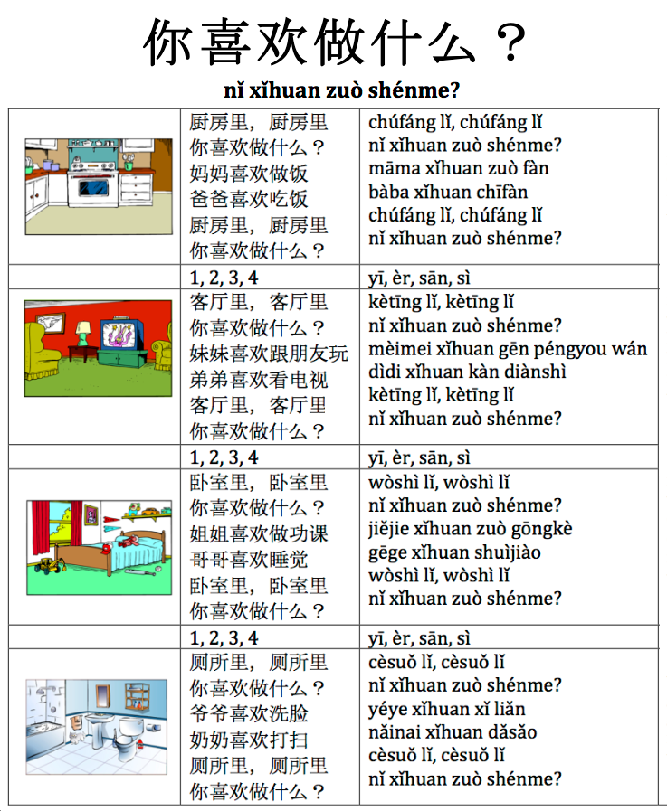

**What Do you Like to Do: Translation**

|  |  |  |  |
| --- | --- | --- | --- |
| In the kitchen, in the kitchen  What do you like to do?  Mom likes to cook.  Dad likes to eat.  In the kitchen, in the kitchen  What do you like to do? | In the living room, in the living room  What do you like to do?  Little Sister likes to play with friends.  Little brother likes to watch TV.  In the living room, in the living room  What do you like to do? | In the bedroom, in the bedroom  What do you like to do?  Elder sister likes to do her homework.  Elder brother likes to sleep.  In the bedroom, in the bedroom  What do you like to do? | In the bathroom, in the bathroom  What do you like to do?  Grandfather likes to wash his face.  Grandmother likes to clean.  In the bathroom, in the bathroom  What do you like to do? |

A wonderful pattern story created by a group of middle school teachers who were studying in Peru is called: ¿Donde vive la Llama? Each frame asks if the llama lives in a specific country and the next frame says that certain other animals live in that country. Finally at the end of the story we find out that the llama lives in Peru!

**¿Donde vive la llama?  (Where does the llama live? )**

|  |  |  |
| --- | --- | --- |
| ¿Vive la llama en Wisconsin?  No, La ardilla vive en Wisconsin?    ¿Vive la llama en la China?  No, el oso panda vive en China?    ¿Vive la llama en la Antártida?  No,  los pingüinos viven en la Antártida.    ¿Vive la llama en Australia?  ¡No, no, no!  El canguro vive y brinca en Australia. | ¿Vive la llama en la India?  No, el elefante vive en la India?    ¿Vive la llama en Zimbabwe?  No, La jirafa, la cebra, el mono, y el león viven en Zimbabwe.    Entonces…  ¿Donde vive la llama?    **¡Vive en Peru!** |  |

Below is the story that two French teachers, Jacqueline Dove and Stephanie Reddin from the Elmbrook (WI) school district wrote as they were teaching a unit about the rain forest. They included the unit’s learning objectives in the format of the story of hummingbird that was looking for the source of the rain.

**Where Does the Rain Come From?**

|  |  |
| --- | --- |
| Description: Rainforest PIcture.jpeg  1. Here is the rain forest in South America. It is hot, humid, and it rains a lot.  2. This is a hummingbird. He is purple, blue, green, and yellow. He is a little bird that drinks nectar. He is sleeping and feels rain drops falling on his head. He wants to see from where the rain drops are coming.  3. The hummingbird starts to fly upwards and sees a tapir. He asks the tapir, "Who are you?"  The tapir replies, "I am the tapir. I am a black mammal. I eat insects. I live on the forest floor."  "No, you are not the rain. Thank you. I am going to continue."  4. The hummingbird flies higher and sees a leaf cutter ant. "Who are you?"  "I am the ant. I am a small, black insect. I eat leaves. I live on the forest floor and in the under story."  "No, you are not the rain. Thank you. I am going to continue." | 5. The hummingbird flies higher and sees a boa. "Who are you?"  "I am the boa. I am a brown reptile. I east small mammals. I live in the under story."  "No, you are not the rain. Thank you. I am going to continue."  6. The hummingbird flies higher and sees a jaguar. "Who are you?"  "I am the jaguar. I am a white, yellow, and brown mammal. I eat small mammals. I live in the understory."  "No, you are not the rain. Thank you. I am going to continue."  7. The hummingbird flies higher and sees a toucan. "Who are you?"  "I am the toucan. I am a black, yellow, red, green, and white bird. I eat fruits. I live in the canopy."  "No, you are not the rain. Thank you. I am going to continue."  8. The hummingbird flies higher and sees a sloth. "Who are you?"  "I am the sloth. I am a brown mammal. I eat plants. I live in the canopy."  "No, you are not the rain. Thank you. I am going to continue."  9. The hummingbird flies higher and sees the sky. It is sunny and it is warm. He sees a macaw. "Who are you?"  "I am the macaw. I am a red, blue, green, and yellow bird. I eat fruits. I live in the canopy and the emergent layer. Why do you ask?"  "I live in the understory. It rains a lot there. Where does the rain come from?"  "It rains up here too. The rain comes from the clouds above. Look! You can see it raining over there."  "Thank you. Now I understand." The hummingbird returns to the understory. He drinks some nectar and it starts to rain again.  "Now I know where the rain comes from." |

**Pattern Stories from Tbilisi, Georgia**

Here are some pattern stories created by a group of teachers at a workshop in Tbilisi the capital of the country of Georgia. The based their stories on the model “In a Dark, Dark, Wood.”

|  |  |
| --- | --- |
| **In a small small room**  In a small small room lives a small small girl  This small small girl has a small small puppy  The small small puppy has a small small mouth  But this small small puppy has a  BIG BIG..  Bark!.......  [*Tinatin Glurjidze*](http://www.facebook.com/profile.php?id=100001577006395)*m and* [*Ann Adamia*](http://www.facebook.com/meGrell)*, Tibilisi, Georgia* | **In a Dark Dark Forest**  In a dark dark forest there was a dark dark castle  And inside the dark dark castle there was a dark dark hall  And in the dark dark hall,there was a dark dark hole  And in the dark dark hole, there lived a dark dark rat  And the dark dark rat was a big big rat  And the dark dark rat was so big that he …  Ate…  A dark dark cat!!  *Kate, Sophie and Tea* |
| **I Love English**  I love love English on Monday.  I love love English on Tuesday.  I love love English on Wednesday.  I love love English on Thursday.  I love love English on Friday  But….  I love love the weekend more than I love love English!  *Tamari Kekelia* | **Are you going to swim on Monday?**  Are you going to swim on Monday? No, I’m not.  Are you going to swim on Tuesday? No, I’m not.  Are you going to swim on Wednesday? No, I’m not.  Are you going to swim on Thursday? No, I’m not.  Are you going to swim on Friday? No, I’m not.  Are you going to swim on Saturday ? No, I’m not.  Are you going to swim on Sunday?  Yes, I am!!  *Natia Arabuli, Eka Chubinidze and Eka Mikadze* |
| **In The Blue Blue Sky**  In the blue blue sky there is an orange orange sun.  And the orange orange sun looks down on the green green earth.  And in the black black night there is a yellow yellow moon and thre are silver silver stars  And the silver silver stars look down on a brown brown house and a red red car  And in the brown brown house with the red red car, there are white white cats and gray gray mice.  And the white white cats and gray gray mice are waiting to wake up to the orange orange sun!  *Teo Burhalaia, Kate Gogichaishuili, Marina Tskadadze and Kate Liluashvili* | **Is it Snowing in March?**  Is it snowing in March? No it’s raining in March.  Is it snowing in April? No it’s blossoming in April.  Is it snowing in May? No it’s time for the flowers to wake up.  Is it snowing in June? No, it’s time to finish your classes.  Is it snowing in July? No, it’s holiday time.  Is it snowing in August? No, it’s sunbathing time.  Is it snowing in snowing in September, October and November? No it’s fall and it’s harvest time.  Well then, when is it snowing??  It’s snowing in December!  *Christine* |

**Pattern Stories Commercially Available**

Here are some popular repetitive books that function as pattern stories:

|  |  |
| --- | --- |
| A Dark Dark Tale (Brown)  Animals Should Definitely Not Act Like People (Barrett)  Are You My Mother? (Eastman)  Brown Bear, Brown Bear, What do You See? (Martin)  Caps for Sale (Slobodkina)  Five Little Monkeys Jumping on the Bed (retold by Christelow)  Goodnight Moon (Wise Brown)  f You Give a Mouse a Cookie (Numeroff)  In My Backyard (De Vries)  Is Your Mama a Llama? (Guarino)  It Looked Like Spilt Milk (Shaw)  Mary Wore Her Red Dress (Peek)  Millions of Cats(Gag)  Mrs. Wishy-Washy (Cowley | Over in the Meadow (Keats)  Polar Bear, Polar Bear, What Do You Hear? (Martin)  The Cat on the Mat (Wildsmith)  The Doorbell Rang (Hutchins)  The Little Engine that Could (retold by Piper)  The Little Red Hen (Galdone)  The Napping House(Wood)  The Very Hungry Caterpillar (Carle)  The Wheels on the Bus (Kovalski)  Today is Monday (Carle)  We're Going on a Bear Hunt (Rosen)  What do You Do with a Kangaroo? (Mayer)  Where's Spot? (Hill)  Whose Mouse are You? (Kraus) |