Espanol I Nombre ____________________________________________
Unit 1 IPA (A)

Context: You are visiting a school in Mexico because your family will be spending a semester there for your mom’s job. During your day in the school you will attend some classes, exchange notes with a student, and then answer the secretary’s questions so that she can enroll you in school.

I. Interpretive Listening
The first class you attend is Español. The teacher shows this video to familiarize the students with an aspect of Spanish culture. Answer as many of the following questions as possible—Write in English!
https://youtu.be/QXc5yx0rWgs

Main Idea. What is this video about? Give the main idea and some details that you understood.
________________________________________________________________________________________________________________________________________________________________________________________________________________________________________________________________________________________________________________________________________________________________________________________________________
Supporting Details. Check each detail that is given in the video. (Not all are mentioned). Then fill in information for the details you have checked.
___ Carnaval is in February ___________________________________________
___ The number of days that Spanish people have off work. _________________
___ The Reyes Magos day is in January. ________________________________
___ The date of the Spanish National holiday ___________________________
___ The Fallas are in March and celebrated with fires. ____________________
___ The date that Spanish presidents are celebrated _____________________
___ They throw tomatoes at each other in August. ______________________
___San Fermín is the running of the bulls in July._________________________

Guessing meaning from Context. Look for the following sentences and write what you think the word in words/phrases in red mean.
1. Carnaval se celebra en febrero. __________________________________
2. San Fermín se celebra en marzo. ________________________

Inference. Answer the following questions in English.
1. What do you think “Los Reyes Magos” are? _____________________________________________________________________
_________________________________________________________________________________________________
2. Do you think that schools in Spain have the same days off as schools in the USA? Why or why not?
______________________________________________________________________________________________________________________________________________________________________________________________________________________________________________________________________________________________________

II. Interpretive Reading:

After the video, the teacher gives you an article from a children’s book, since the classwork would be too difficult for you. Read the article and complete the following comprehension guide.

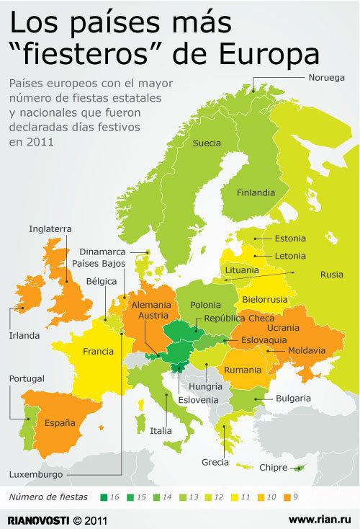

A. Key Word Recognition. Find the Spanish words/phrases that best express the meanings of the following English
words/phrases.

France ___________________________
Europe__________________________________
Rusia __________________________________
Spain __________________________________
Belgium__________________________________
Switzerland__________________________________
Germany__________________________________
England__________________________________
Italy______________________________________
days_____________________________________
number_________________________________
fiestas__________________________________

B. Main Idea. What is the purpose of this text? Write 2-3 sentences in English.

______________________________________________________________________________________________________________________________________________________________________________________________________________________________________________________________________________________________________

C. Supporting Details. Check each detail that is given in the article. (You will not check every detail.) Then fill in the information that is given for each detail. Write in English.

___ Which country had the most holidays____________________________________________________
___ Which country had the least holidays_____________________________________________________
___ The country had more holidays France or Spain____________________________________________
___ The official language(s) of Switzerland ___________________________________________________
___ The name of the King of Spain______________________________________________________
___ Which countries boarder Spain__________________________________________________________
___ The official language(s) of Monaco _____________________________________________________________
___ The name of Spain’s national anthem __________________________________________________
___ The official language(s) of Luxembourg ___________________________________________________________
___ The year of this infographic __________________________________________________________

D. Guessing Meaning from Context. Find the underlined words/phrases and write what you think they mean in English. The words in parenthesis tell you where the word is located.

1. mayor __________________________
2. paises____________________________________________________
3. fiesteros ________________________________

E. Inference. Answer the following question in English. Use information from the article to support your answer.
1. Why do you think there are so many holidays in Finland, Norway, and Spain?
______________________________________________________________________________________________________________________________________________________________________________________________________________________________________________________________________________________________________

F. Comparing Cultural Perspectives. Answer in English.
1. Why do you think we have one official language in the U.S., but many European countries have more than one official language?
________________________________________________________________________________________________________________________________________________________________________________________________________________________________________________________________________________________________________________________________________________________________________________________________________
III. Presentational Writing: The person sitting next to you in geography class passes you a note. Write a response on the blank page. Make sure to answer Miguel’s questions in as much detail as possible. You should even try asking a couple questions of your own!
Hola
¿Cómo estas?
Me llamo Miguel.
¿Cómo te llamas?
¿Cuántos años tienes?
Hasta pronto!

IV. Interpersonal Speaking: Before you leave the school, the school secretary (Madame) needs some information so that she can enroll you for next year. Respond appropriately to her statements and questions.
This is the “secretary’s” script:
Hola
¿Cómo estás?
¿Cómo te llamas?
¿Cómo se escribe?
¿Cuántos años tienes?
¿Cuándo es tu cumpleaños?
Muchas gracias,
Hasta pronto!

